R. Reports Menu: B. Deposits Report

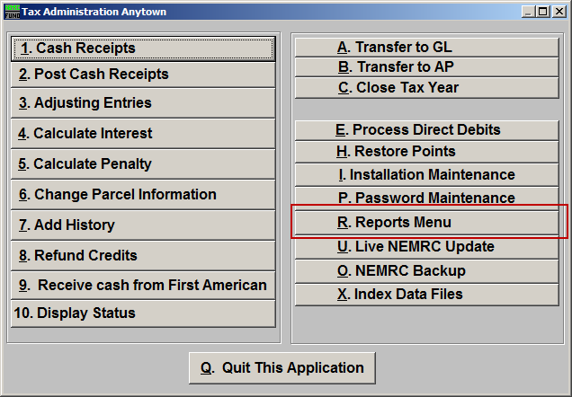
Click on “R. Reports Menu” from the Main Menu and the following window will appear:

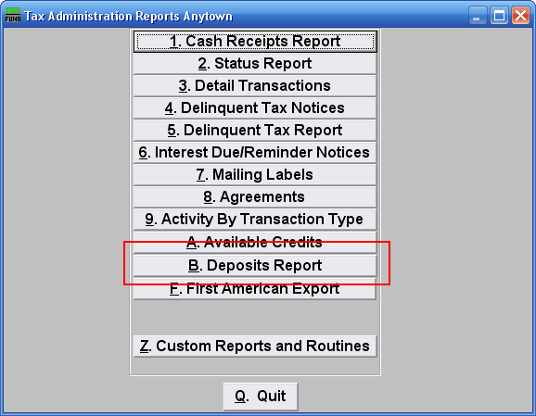
Click on “B. Deposits Report” from the Reports Menu and the following window will appear:
Deposits Report

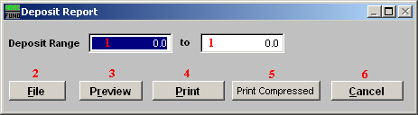
- Deposit Range: Enter the deposit number range for which you wish the summary deposit report to show. This report is a summary of the totals that can be found from the Cash Receipts Report (from the “R. Reports Menu”) on posted deposit numbers.

- File: Click this button to save on this computer. Refer to GENERAL FILE for more information.

- Preview: Click this button to preview. Refer to GENERAL PREVIEW for more information.

- Print: Click this button to print. Refer to GENERAL PRINTING for more information.

- Print Compressed: Click this button to print. This is different from the “Print” option in that it will use less paper for the same report.

- Cancel: Click “Cancel” to cancel and return to the previous screen.

